2021 Kent County Fair Baby Contest
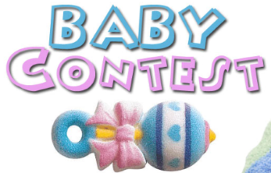
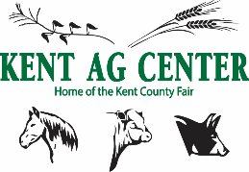
Friday, July 16, 2021
5:00 PM

Theme: “Once Upon a Fair-y Tail”

Rules and Regulations

Contestants will be judged on how well they represent the fair theme.
Be creative and show your fair spirit!

- Open to General Public
- Age is determined as of the date of contest
- Pre-Registration is not required, but registration must be complete by 4:30 PM the day of the contest. (July 16, 2021)
- Prizes will be awarded to the Winner and Runner-up in each age division category
- Entry Fee $3.00 per child

Class - Age Divisions

Female Male
BC0F 0-1 year  BC1F 1 year old  BC2F 2 year old  BC3F 3 year old | BC0M 0-1 year  BC1M 1 year old  BC2M 2 year old  BC3M 3 year old
----------------------------------------------------------------------------------------------------------------------------
2021 Kent County Fair Baby Contest Entry Form

Child’s Name: _________________________________ Birth Date: ____________________

Gender: _____________ Class: ______________

Parent/Guardian Name: _______________________________________________________

Phone: ____________________________

Address: ___________________________________________________________________
I will not hold the Kent Ag Center liable for any accident or injury which may occur while my child is participating in the Kent County Fair.

Parent Signature: Date:

