2019 Kent County Fair Baby Contest
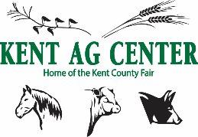
Friday, July 19, 2019
5:00 PM

Theme: “Dream the Green”

Rules and Regulations

Contestants will be judged on how well they represent the fair theme.
Be creative and show your fair spirit!

- Open to General Public
- Age is determined as of the date of contest
- Pre-Registration is not required, but registration must be complete by 4:30 PM the day of the contest. (July 19, 2019)
- Prizes will be awarded to the Winner and Runner-up in each age division category
- Entry Fee $3.00 per child

Class - Age Divisions

Female Male
BC0F 0-1 year  BC1F 1 year old  BC2F 2 year old  BC3F 3 year old | BC0M 0-1 year  BC1M 1 year old  BC2M 2 year old  BC3M 3 year old
----------------------------------------------------------------------------------------------------------------------------
2019 Kent County Fair Baby Contest Entry Form

Child’s Name: _________________________________ Birth Date: ____________________

Gender: _____________ Class: ______________

Parent/Guardian Name: _______________________________________________________

Phone: ____________________________

Address: ___________________________________________________________________
I will not hold the University of Maryland or the Kent Ag Center liable for any accident or injury which may occur while my child is participating in the Kent County Fair.

Parent Signature: Date:

